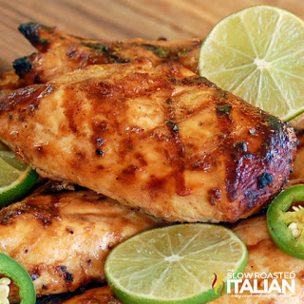
Grilled Margarita Chicken
Prep Time 20 min Cook Time Grill 10 min/Oven 60 min
4 Servings
Ingredients
1 lb boneless skinless chicken breasts (washed and trimmed)
Zest of 1 lime (about 1 tbsp)
Juice of 3 limes (about ½ cup)
Juice of 1 orange (about ¼ cup)
1 jalapeño pepper, minced (seeded and deveined to reduce heat)
5 cloves garlic, minced or grated
2 tsp ground cumin
1 tsp ground coriander seed
1 tsp kosher salt
½ tsp fresh ground black pepper
¼ cup Cuervo Gold tequila
¼ cup extra virgin olive oil
Directions
- Place chicken in a resealable gallon size plastic bag. Set aside.
- Add all ingredients, except chicken, in a small bowl or measuring cup. Whisk to combine. Reserve ½ cup of remaining marinade and place in the refrigerator.
- Pour the marinade over the chicken, seal and place in the refrigerator to marinate for 3-24 hours. Turn chicken occasionally.
- Preheat grill to medium-high. Place chicken on the counter to take the chill off, about 30 minutes.
- Grill chicken about 4-5 minutes on each side, turning half-way to get great grill marks.
- Heat reserve marinade and serve over chicken and vegetables if desired.

Oven Directions
- Preheat oven to 350 degrees.
- Pour off half the marinade. Add chicken and reserved marinade to a 9 x 13 baking dish and bake for 26 minutes convection oven (bake in oven for 35 minutes), until cooked through. Internal temperature should be 165 degrees.

